CRIM 0368 - Credit Manager Lobby

|  |  |  |  |  |
| --- | --- | --- | --- | --- |
| **Ver** | **Date** | **Author** | **Comments** | **Reviewed by** |
| 1 | 16/11/2020 | Tom Bell | CRIM 0368 | TBC |
| 3 | 17/03/2021 | Tom Bell | Removed invoicing lobby elements section. |  |
| V4 | 28/05/2021 | Tom Bell | Target lobby element changes. Prospect Credit Check Lobby Element |  |

Requirements 2

Prerequisites 2

Solution Overview 2

Solution Details 2

Security 3

Companies 3

Data Migration 3

Test Steps 3

Technical Implementation 3

Requirements

The system must provide a lobby that Credit Managers can use to navigate to different parts of the system, work items and manage Credit Analyst Escalations/KPIs.

Prerequisites

* CRIM 0343 for Creating Invoice Notes.
* CRIM 0330 for Aging Buckets.
* CRIM 0367 for Credit Analyst Lobby.
* CRIM 0333 for Sending Partial Statement
* CRIM 0392 for Creating Queries

Solution Overview

**Context**: Credit Manager logs into IFS and their main work will be driven from this lobby. The lobby will have a filter at the top to filter by Credit Manager.

This lobby will be similar to the Credit Analyst’s Lobby but with extra functionality. 28 lobby elements in total, including tiles, charts and basic data.

**Credit Manager’s Tiles (non-team)**

* Call List
* Overdue Debt
* Customer Payment on Account
* Top 10 Customer Debt (By Aging Bucket)
* Top 10 Largest Items (By Aging Bucket)
* Overdue Queries Tile
* Open Queries Tile
* Target Doughnut chart
* Ad hoc Sending of Full Statement
* Ad hoc Sending of Partial Statement
* Blocked Customers
* Customer Credit Usage

**Credit Management Tiles**

* Age of Debt for all Customers by Stat Group
* All Blocked Customers
* All Top 10 Total Customer Debt by Aging Bucket
* All Top 10 Items by Aging Bucket
* Follow Up Date Missed
* All Overdue Debt
* All Customer Payment on Account
* All Queries (Overdue and Open)
* Open Items by Credit Analyst
* Credit Targets Basic Data
* Large Invoice Courtesy Call.
* Legal Customers
* Escalated Items for Review
* ~~Monthly Target % by Credit Analysts Chart~~
* All Customer Credit Usage
* Escalated to Finance Controller Tile
* Prospect Requires Credit Check Lobby Element
* Targets Lobby Element List
* Team Targets Lobby Element List

The below screenshot shows a rough overview of what the Credit Manager’s lobby should look like.

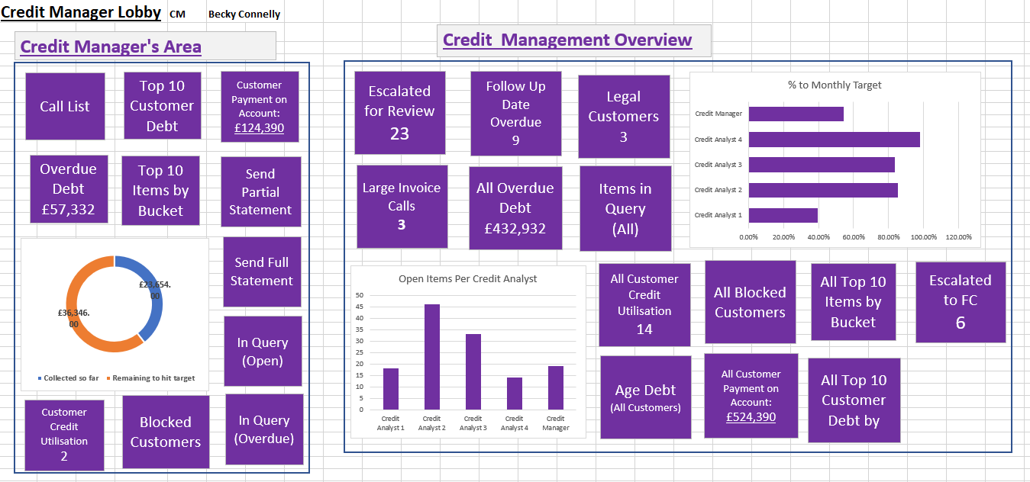

Solution Details

The below section details what functionality the Credit Manager Lobby requires.

# Lobby Filter

A filter is required at the top of the lobby with a drop down to filter by Credit Manager. This filter will only be available to the Credit Manager.

The below screenshot shows an IFS stock Credit Management lobby. The red box shows where a filter needs to be placed to filter by Credit Manager.

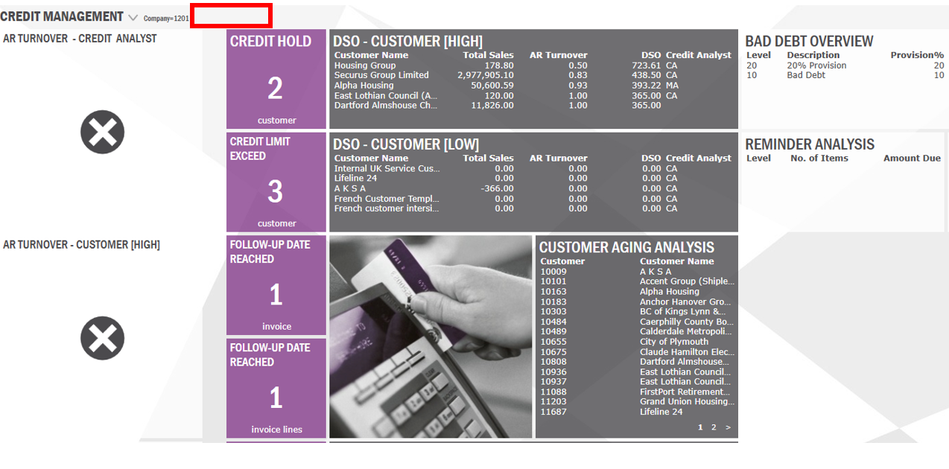

# Call List Tile (Customer Credit Analysis Screen)

Clicking into this tile will bring the Credit Manager to the Customer Credit Analysis Screen. A title is needed at the top of this Screen named “Call List”.

By clicking into this tile from the Lobby, the Credit Manager is brought to the “Customer Credit Analysis” screen with a saved search that filters only Customers assigned to that Credit Manager.

Conditional formatting must be applied to this screen to only show Customers where the most recent Invoice Header Credit Note “Follow Up Date” is equal to or older than today’s date. (Older notes will be ignored).

The Call List screen must include Customers that have no Invoice Header Credit Notes attached to them and the item is not in Aging Bucket – Current.

**Call List Conditional Formatting/Filter Summary:**

* Filter the Call List to only show Customers where the most recent Invoice Header Credit Note “Follow Up Date” is less than or equal to the current date and the item is overdue. (where Aging Bucket is not Aging Bucket - Current).
* Filter the Call List to show Customers that have no Invoice Header Credit Notes attached to them.
* Filter list to exclude customers where the most recent Invoice Header Credit Note has a Note status of: “Note Status 1 – Complete” or “Note Status 2 – Escalated to Credit Manager”.

**Example**

The below screenshot shows the Invoice Header Note screen for a customer. Today’s date is the 17/11/2020. This customer item will be filtered out of the Call List as the most recent Note is not due for a Follow Up until the 19/11/2020.

On the date 19/11/2020 this Customer will appear in the Call List screen as the Follow Up Date has been reached and the Notes must be updated.

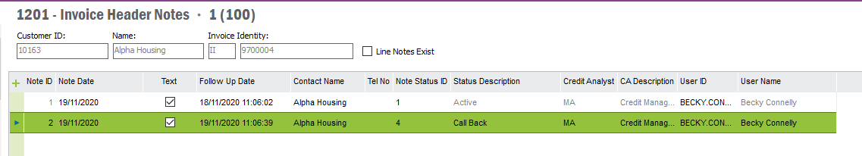

The below screenshot shows that the latest Note Status for this item has now been set to “Complete”. This customer and item will be excluded from the Call List screen.

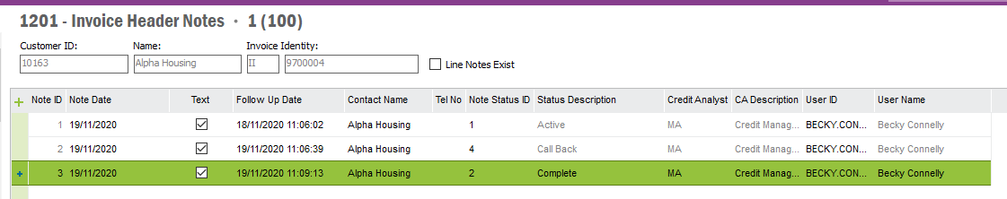

The below table lists the Note Statuses and whether the Call List filter should include these items or not.

**Note Status Inclusion List**

|  |  |  |
| --- | --- | --- |
| **Note Status ID** | **Status Description** | **Include in Call List** |
| 1 | Complete | NO. |
| 2 | Escalated to Credit Manager | NO. |
| 3 | Credit Manager Resolved | YES. |
| 4 | Cheque in Post | YES. |
| 5 | Payment Promise | YES. |
| 6 | BACS/Remit Received | YES. |
| 7 | Additional Comment | YES. |
| 8 | Copy Invoice Requested | YES. |
| 9 | Message Left | YES. |
| 10 | 7 Day Letter | YES. |
| 11 | Credit Balance | YES. |
| 12 | Payment Certificate Received | YES. |
| 13 | Incoming Call | YES. |
| 14 | LA Cash | YES. |
| 15 | Legal | YES. |
| 16 | Outgoing call/email | YES. |
| 17 | Statement Requested | YES. |
| 18 | Proforma | YES. |
| 19 | In Query | YES . |
| 20 | Request Customer Block | YES. |
| 21 | Escalated to Finance Controller | NO. |
| 22 | Finance Controller Resolved | YES. |

**Additional Column Requirements in Call List (Customer Credit Analysis Screen)**

* Largest Overdue Debt
* Oldest Overdue Debt
* Follow Up Date (Of most recent Invoice Header Note)

|  |  |
| --- | --- |
| **Column Name** | **Column Data Description** |
| Largest Overdue Debt | Largest item that is overdue amount. |
| Oldest Overdue Debt | Oldest Item that is overdue amount. |
| Follow Up Date | Oldest follow up date on the most recent Invoice Header Note. |

# Overdue Debt Tile (Customer Credit Analysis Screen)

By clicking into this tile, the Credit Manager is brought to the Customer Credit Analysis screen with a saved search that only shows customers linked to that Credit Manager with overdue debt on their account (any customer who’s item(s) that are not in Aging Bucket – Current).

The Overdue Debt tile would also have on the total overdue debt for that Credit Manager.

Additional, columns are required for this screen include:

|  |  |
| --- | --- |
| **Column Name** | **Column Data Description** |
| Largest Overdue Debt | Largest item that is overdue amount. |
| Oldest Overdue Debt | Oldest Item that is overdue amount. |
| Follow Up Date | Earliest follow up date on Customer Credit Management Notes. |

A title is needed on this screen named “Overdue Debt” where the red box is on the screenshot below.

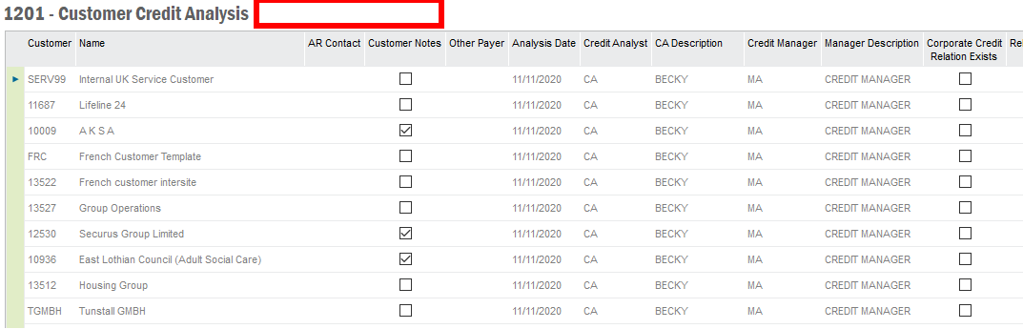

# All Overdue Debt Tile (Customer Credit Analysis Screen)

By clicking into this tile, the Credit Manager is brought to the Customer Credit Analysis screen with a saved search that only shows customers who have Over Due debt on their account.

The All Overdue Debt tile needs the total overdue debt for all Credit Analysts and Credit Managers on the tile, visible from the lobby.

Additional, columns are required for this screen include:

|  |  |
| --- | --- |
| **Column Name** | **Column Data Description** |
| Largest Overdue Debt | Largest item that is overdue amount. |
| Oldest Overdue Debt | Oldest Item that is overdue amount. |
| Follow Up Date | Earliest follow up date on Customer Credit Management Notes. |

A title is needed on this screen named “All Overdue Debt” where the red box is on the screenshot below.



# Top 10 Total Customer Debt per Aging Bucket

This tile will show a screen that has the Largest Customer Debt by Aging Bucket. Customer Number, Customer Name and Balance in Bucket as column headers and customer debt as rows. Sorted by largest customer balance descending. Only Customers would appear there that are assigned to the Credit Manager.

The below screenshot shows a rough example of the tile that is required.

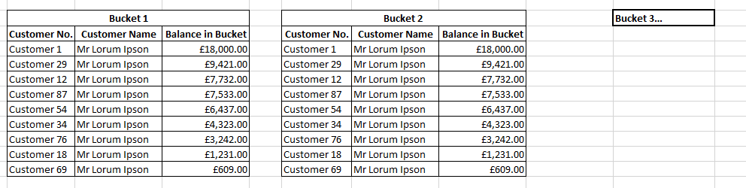

From this element an RMB on an item will show the same RMB options as the Customer Credit Analysis screen. See the below screenshot.

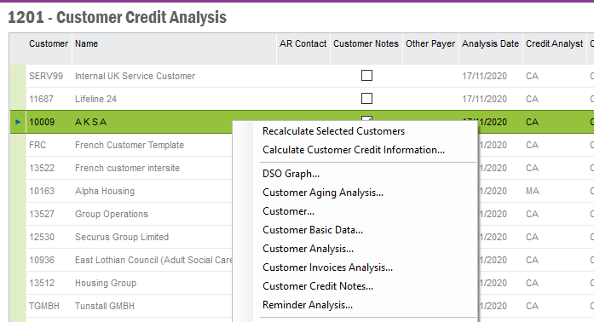

# All Top 10 Total Customer Debt per Aging Bucket

This tile will show a screen that has the Largest Customer Debt by Aging Bucket. Customer Number, Customer Name and Balance in Bucket as column headers and customer debt as rows. Sorted by largest customer balance descending. All Customers need to be included in this screen.

The below screenshot shows a rough example of the tile that is required.



From this element an RMB on an item will show the same RMB options as the Customer Credit Analysis screen. See the below screenshot.



# Top 10 Items (Per Aging Bucket)

This tile will show the largest overdue debt by invoice amount. Sorted by largest open item. This screen would only show Invoices that belong to a Customer that is assigned to the Credit Manager.

Aging Buckets as columns and invoices as rows.

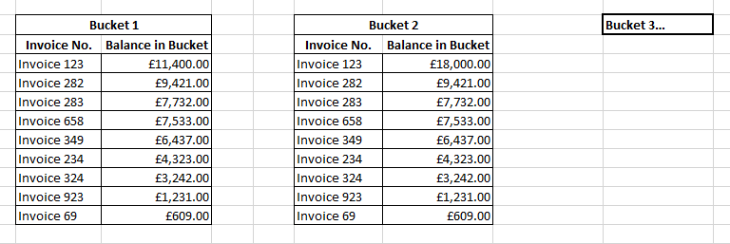

From this screen an RMB on an item will show the same RMB options as RMB on an invoice from the Customer Analysis (Ledger Tab) screen. The below screenshot shows the RMB options that are required from the Top 10 Items by Aging bucket screen when RMB on an item.

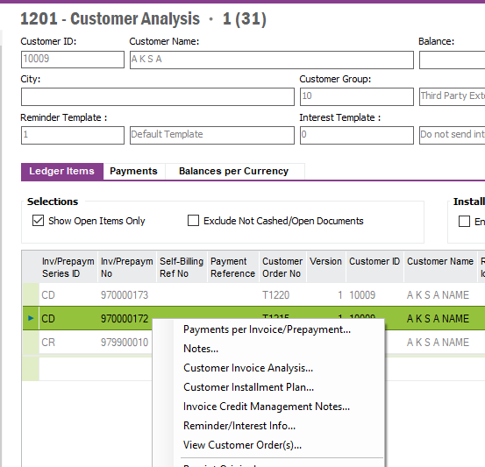

# All Top 10 Items by Aging Bucket

This tile will show the largest overdue debt by invoice amount. Sorted by largest open item. This screen would only show Invoices for all customers.

Aging Buckets as columns and invoices as rows.



From this screen an RMB on an item will show the same RMB options as RMB on an invoice from the Customer Analysis (Ledger Tab) screen. The below screenshot shows the RMB options that are required from the Top 10 Items by Aging bucket screen when RMB on an item.



# Blocked Customer Tile

This tile lists the Customers that are assigned to the Credit Manager that have been blocked. The Credit Blocked indicator is on the Customer Master Record (see red box in below screenshot). This is subject to the Credit Manager filter within the lobby.

This tile will navigate to the Customer Credit Management screen and be filtered to only shows Blocked Customers on this screen.

The below screenshot shows the Customer data screen where the “Credit Blocked” button that would trigger the customer appearing in the Blocked Customer tile described above.

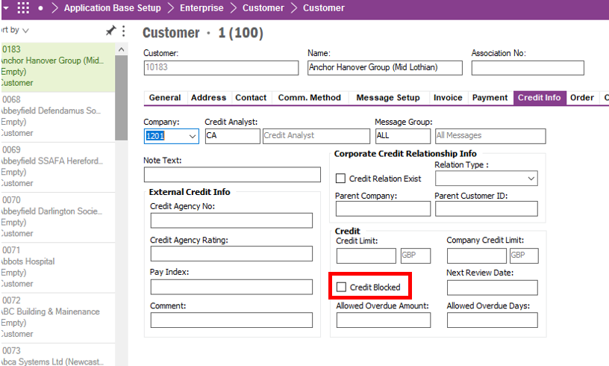

# All Blocked Customers Tile

This tile lists the all Customers that have been blocked. The Credit Blocked indicator is on the Customer Master Record (see red box in below screenshot).

This tile will navigate to the Customer Credit Management screen and be filtered to only shows Blocked Customers on this screen.

The below screenshot shows the Customer data screen where the “Credit Blocked” button that would trigger the customer appearing in the Blocked Customer tile described above.



# Customer Payment On Account

Require a Tile called “Customer Payment on Account”. Within this Tile Customer Analysis screen will be shown with a filtered applied to the list to only show customers with Customer Payments on Account.

Require a filter on the Customer Analysis Screen that only shows customers with “Invoice Prepayment Series ID” = CUPOA (Customer Payment on Account) that is not zero for Open Amount.

Require a title at the top of this screen that reads “Customer Payment On Account”. On the tile from the lobby, the Tile will show the total Customer Payment on Account for Customer’s assigned to the Credit Manager with Payment ID CUPOA. The below screenshot shows a rough example of what the tile could look like from the lobby.

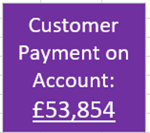

The below screenshot shows the Customer Analysis screen with an example customer with the Invoice Series ID CUPOA (in red box).

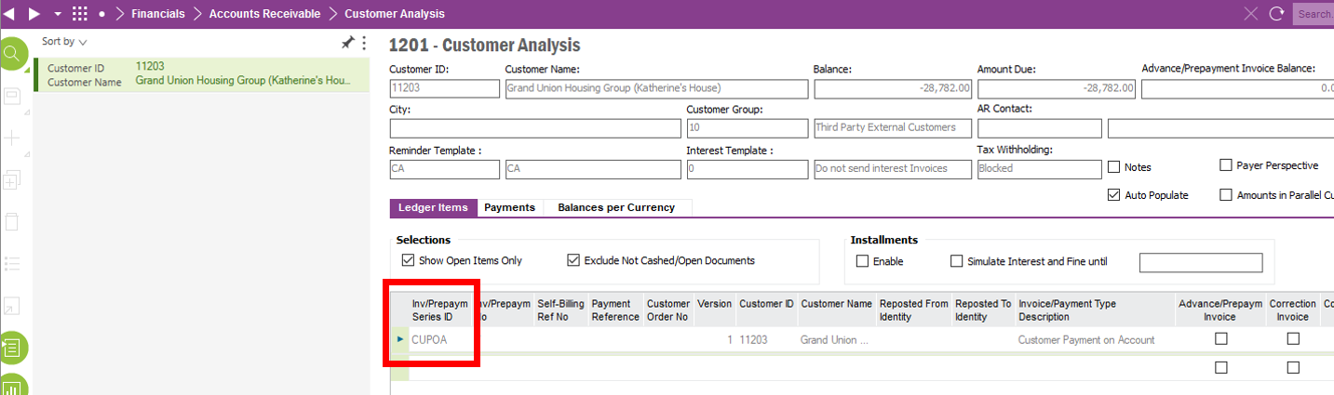

# All Customer Payment On Account

Require a Tile called “Customer Payment on Account”. Within this Tile Customer Analysis screen will be shown to show all customers with Customer Payments on Account.

Require a filter on the Customer Analysis Screen that only shows customers with “Invoice Prepayment Series ID” = CUPOA (Customer Payment on Account) that is not zero for Open Amount.

Require a title at the top of this screen that reads “Customer Payment On Account”. On the tile from the lobby, the Tile will show the total Customer Payment on Account for Customer’s assigned to the Credit Manager with Payment ID CUPOA. The below screenshot shows a rough example of what the tile could look like from the lobby.



The below screenshot shows the Customer Analysis screen with an example customer with the Invoice Series ID CUPOA (in red box).



# Escalated to Credit Manager Tile

By clicking into this tile, the Credit Manager is brought to the Customer Credit Analysis screen.

Here this screen needs to be filtered to only show Customers who have items that have “Status 2 – Escalated to Credit Manager” Invoice Header Notes as the most recent Credit Note. This gives the Credit Manager a view of what they need to work on.

From the lobby the tile should show the total of invoices that have the most recent Invoice Header Note set to the “Note Status 2 - Escalated to Credit Manager” or Note Status 20 – “Request Customer Block”.

This is screen will show all Customers for all Credit Analysts.

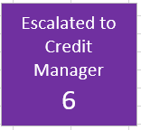

**Example:** Credit Manager can see on tile that there are escalated items to action. Credit Manager reads the note history on the escalated items, works through the issue and then created a new Invoice Header note with Note Status 3“Credit Manager Resolved”. This would remove the item from the Escalated to Credit Manager screen and back to the Credit Analyst’s Call List.

**Conditions and filtering**

This screen is populated with customers who have Invoice Header Notes on items where:

* The most recent Note Status is Note Status 3 - “Escalated to Credit Manager”.
* The most recent Invoice Header Note Status 20 – “Request Customer Block”.
* The screen will have the title Escalated to Credit Manager.

The screen will have the title Escalated to Credit Manager.

# Follow Up Date Missed

Selecting this Tile brings the Credit Manager to the Follow Up Date Missed screen (Customer Credit Analysis screen). From the Credit Manager Lobby, this tile will have the number of items that have Follow Up Dates that are overdue.

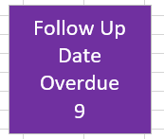

This screen will contain Customers who have invoice Credit Header Notes where the most recent Follow Up Date is 4 working days old or more.

This screen will include Customers with Invoices that have no Invoices Header Notes on them for more than 4 working days since not paying the invoice and where items are overdue.

Customers with Invoices that have the same Invoice Header Credit Notes entered consecutively will also be included in this screen.

**Conditions for appearing in this screen (Filter).**

* Invoice is overdue and no Invoice Credit Header Note for 4 working days.
* Invoice Credit Header Note Follow Up Date is older than 4 working days for overdue invoices.
* If Invoice Credit Header Note Status has been input twice consecutively.

**Context:** This screen is used by the Credit Manager to ensure that items are being worked by the Credit Analyst. From this screen the Credit Manager can look at the Customer Analysis screen and see the transactions and note history etc. The Credit Manager can then chase the Credit Analyst to follow this work up. If either the Credit Manager or the Credit Analyst adds a note to the item, it will be removed from this Follow Up Date missed screen.

All RMB options available from the Customer Credit Analysis screen must be available in this screen.

The screen will have the title Follow Up Date Missed.

# Age of Debt: Per Customer Stat Group

Selecting this Tile will show a screen that has Customer Debt by Stat Group by Aging Bucket. Sorted by largest Stat Group balance descending.

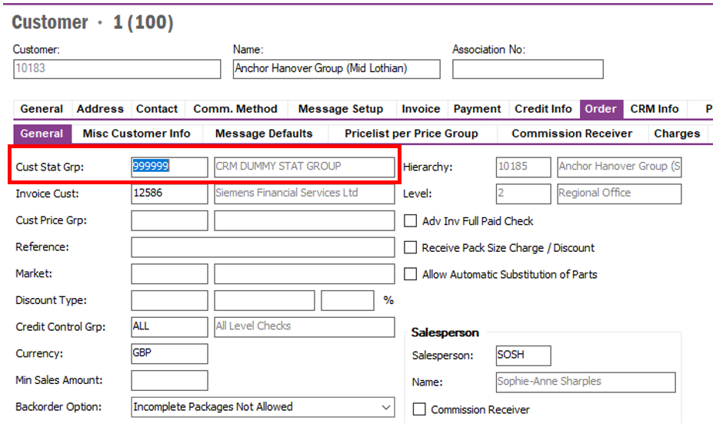

The below screenshot shows a rough example of the tile that is required.

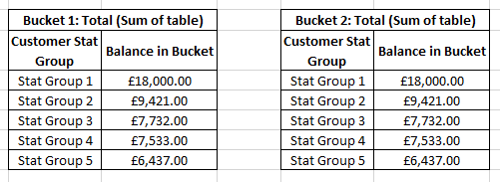

This screen is not limited to any Customer filter. It shows data for all customers irrespective of Credit Analyst/Manager Assignment.

Basic data for Cust Stat Group is TBC as of 20/11/2020. See Tom Bell / Matthew Colley for more info.

Need a revenue stream report in addition to this report 24/11/2020. See Tom Bell / Matthew Colley for more info.

# Credit Targets Basic Data

The system must have a new tab on the Credit Management basic data screen called “Credit Targets”. Here the Credit Analysts will be listed along with their target. This table will be used for target reporting.

The screenshot shows a brief example of the table that is required.

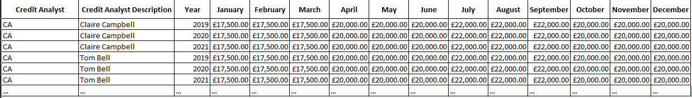

NOTE: This table is only editable by the Credit Manager/Finance Controller.

The below screenshot sows where the basic data tab for Credit Targets should be located.

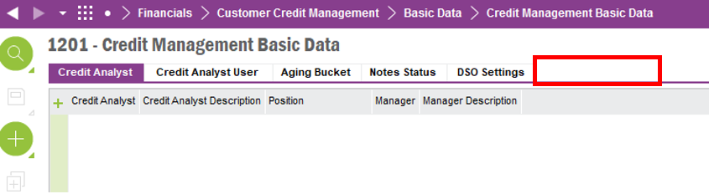

# Monthly Target % by Credit Analyst Chart

The below bar chart is generated from the Credit Management basic data, Credit Analyst Targets table. This bar chart will show the Credit Analyst’s collected cash as a % against their target for that month.

Credit Analyst on the Y axis and % of Target (Collected Amount/Target*100) on the X axis.

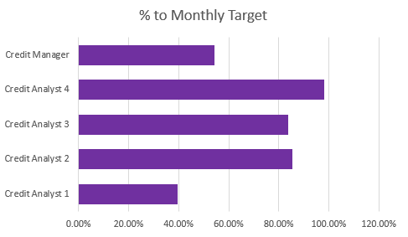

# Open Items by Credit Analyst

This bar chart will show the number of unpaid items assigned to that Credit Analyst’s customers.

Clicking into he below bar chart will bring the user to a screen that shows the table below.

The bar chart will be generated from this table that shows the following data: Credit Analyst and Open Items (Number of Open Items in All Aging Buckets per credit Analyst)

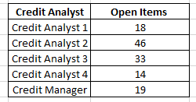

An RMB from this screen will have an option to “Go to Credit Analyst X – Call List”. This will zoom to that Credit Analyst’s Call List (Customer Credit Analyst screen).

The below screenshot shows an example of a bar chart that will be featured on the Credit Manager’s Lobby.

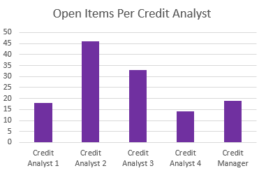

# Large Invoice Courtesy Call.

By clicking into this tile, the user is brought to a Customer Credit Analysis screen where customers with open invoices over £10,000 are shown.

The below screenshot shows an example of the tile that is required. The number of Large Invoices is shown here.

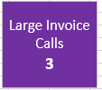

**Conditional Formatting/Filtering**

* Filtered to only show Customers with an unpaid invoice over £10,000.

# Legal Customers Tile

By clicking into this tile, the user is brought to a Call List screen (Customer Credit Analysis screen) to only show customers with the latest Note Status 15 “Legal”. These are customer who have not paid, and AR have passed their details over to Solicitors.

The below screenshot shows the tile as viewed from the Lobby screen. The number on the tile is the number of customers with latest Invoice Header Credit Note Status 15 “Legal”.

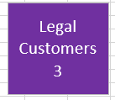

**Conditional Formatting/Filter:**

* Filter to only show customers with the latest Invoice Credit Header Note status set to “Note Status 15 – Legal”.

Needs to be training around this process. When a customer is passed over to legal and a legal Note Status added. They need to update the Message Type/Customer Model.

# Open Queries Tile

Screen for showing items in query, where business owners need to rectify Queries on invoices. This screen needs to show the Customer Credit Analysis screen that has been filtered to only show customers with the latest Note Status set to “In Query”, the follow up date after today’s date and the item is unpaid.

The below screenshot shows the tile that is required. The number of items in query that are open (not overdue) should be shown on this tile (“Note Status – In Query” & Follow Up Date after today’s date).



**Conditional Formatting/Filter:**

* Filter to only show customers with the latest Invoice Credit Header Note status set to “In Query” and the Follow Up Date after today’s date.
* Filtered to only show Credit Manager’s customers

# Overdue Queries

Screen for showing items in query, where business owners need to rectify Queries on invoices. This screen needs to show the Customer Credit Analysis screen that has been filtered to only show customers with the latest Note Status set to “In Query”, the follow up date before today’s date. And the item is unpaid.

The below screenshot shows the tile that is required. The number of items in query that are overdue should be shown on this tile (“Note Status – In Query” & Follow Up Date before today’s date).

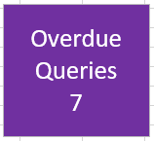

**Conditional Formatting/Filter:**

* Filter to only show customer with the latest Invoice Credit Header Note status set to “In Query” and the Follow Up Date before today’s date.
* Filtered to only show Credit Manager’s customers

# All Queries (Overdue and Open)

Screen for showing items in query, where business owners need to rectify Queries on invoices. This screen needs to show the Customer Credit Analysis screen that has been filtered to only shows customers with latest note status set to “In Query”. This will NOT be filtered by Credit Analyst or Manager but will show all Customers

The below screenshot shows the tile that is required. The number of items in query that are overdue should be shown on this tile (“Note Status – In Query” & Follow Up Date before today’s date).



**Conditional Formatting/Filter:**

* Filter to only show customers with the latest Invoice Credit Header Note status set to “In Query” and the item is unpaid.

# Customer Credit Usage Screen

This screen will show the Customer Credit Analysis screen with the same column headers as the Call List. This screen will be sorted by the column “Credit Limit Usage %” descending. The customer’s who’ve used the most Credit will be at the top of this screen and will be filtered to only show customer assigned to the Credit Manager.

The below screenshot shows an example of what this tile should look like from the Lobby. The number below the text is the “Number of Customer’s whose credit Utilisation is 95% or over”. This will give the Credit Manager a good way to track customer’s who are nearing the max of their limit.

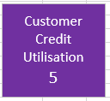

**Conditional Formatting/Filtering**

* Filtered to only show Customer’s assigned to the Credit Manager.

**Extra Columns in Credit Usage screen (Customer Credit Analysis Screen)**

* **Customer Credit Limit Total –** Total Credit limit on customer account
* **Customer Credit Limit Usage –** How much credit the customer has current used.
* **Credit Limit Usage % -** What % of their Credit limit has the customer used?
* **(From Call List screen)** Largest Overdue Debt
* **(From Call List screen)** Oldest Overdue Debt
* **(From Call List screen)** Follow Up Date (Of most recent Invoice Header Note)

# All Customer Credit Usage Screen

This screen will show the Customer Credit Analysis screen with the same column headers as the Call List. This screen will be sorted by the column “Credit Limit Usage %” descending. The customer’s who’ve used the most Credit will be at the top of this screen.

The below screenshot shows an example of what this tile should look like from the Lobby. The number below the text is the “Number of Customer’s whose credit Utilisation is 95% or over”. This will give the Credit Manager a good way to track customers who are nearing the max of their limit. This screen will not be filtered by Credit Manager and will show data for all customers.

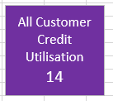

**Extra Columns in Credit Usage screen (Customer Credit Analysis Screen)**

* **Customer Credit Limit Total –** Total Credit limit on customer account
* **Customer Credit Limit Usage –** How much credit the customer has current used.
* **Credit Limit Usage % -** What % of their Credit limit has the customer used?
* **(From Call List screen)** Largest Overdue Debt
* **(From Call List screen)** Oldest Overdue Debt
* **(From Call List screen)** Follow Up Date (Of most recent Invoice Header Note)

# Ad Hoc Sending of Full Statement Tile

When clicking this tile, a dialogue box opens that asks for the Customer Name. Once confirmed the Customer Name/Number, the Credit Analyst would select “Send Statement” which would open the Customer Statement of Account report generation dialogue box as shown below. With the Full Statement of Account report attached.

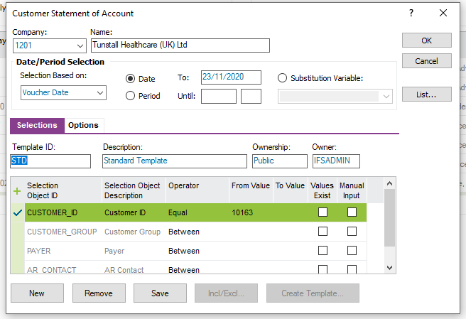

After confirming the options in the above parameters, the Credit Analyst will select “OK” and the below dialogue box would open.

Here the selected Customer’s email address would auto-populate (with the ability to manually input an email is require - editable). Selecting “OK” would send the statement to the customer via email.

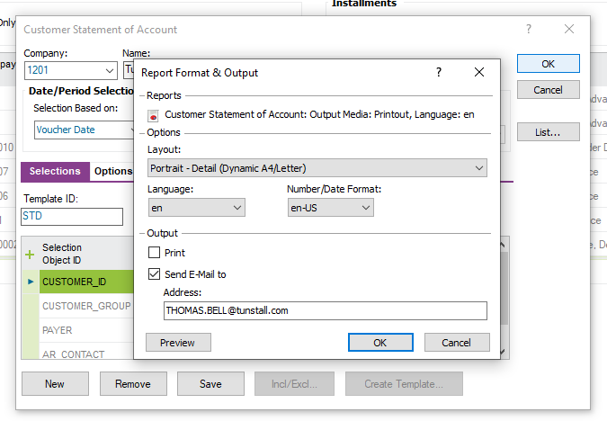

# Ad Hoc Sending of Partial Statement Tile

When clicking this tile, a dialogue box opens that asks for the Customer Name. Once confirmed the Customer (Name/Number), this navigates to the Customer Analysis screen for that Customer. From here the normal Sending of Partial Statement process would be followed (CRIM 0333).

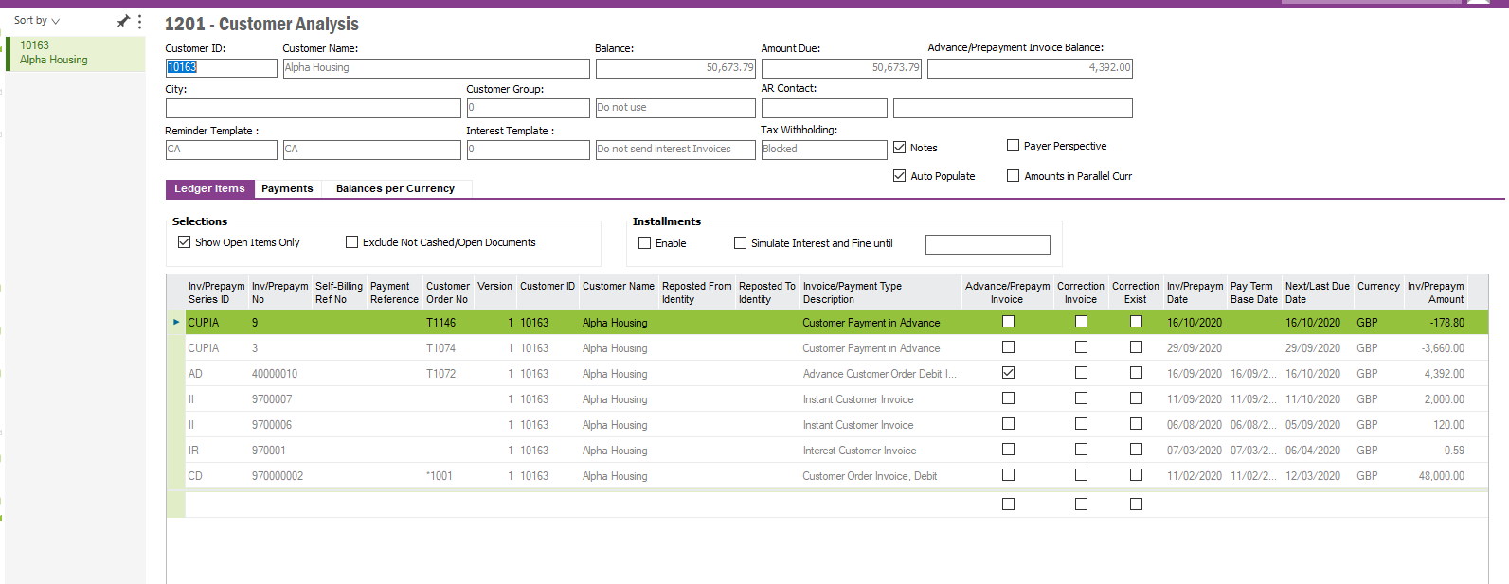

# ~~Target Doughnut Chart~~

~~A doughnut chart is needed from the lobby that shows how much cash that Credit Analyst has collected as well as the cash that needs to be collected for the Credit Analyst to hit their target.~~

* **~~Cash Collected~~** ~~– Cash Collected by Credit Analyst for that calendar month.~~
* **~~Remaining to Hit Target~~** ~~– (Monthly Target – Cash Collected) = Remaining~~

~~The Target basic data is described in in the “Credit Targets Basic Data” section for this document. It will be located in a new tab in the Credit Management Basic Data screen.~~

~~The below chart shows an example of what is required.~~

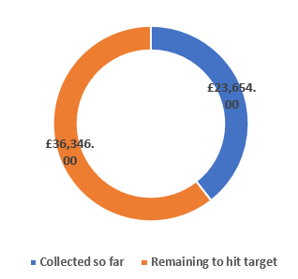

# Customers with No Credit Analyst

This lobby element will contain a saved search on the Customer Credit Analysis screen that only shows Customers if the “Credit Analyst” field is blank.

The below screenshot shows the screen that this lobby element needs to link to. It shows example data that must be shown using a saved search.

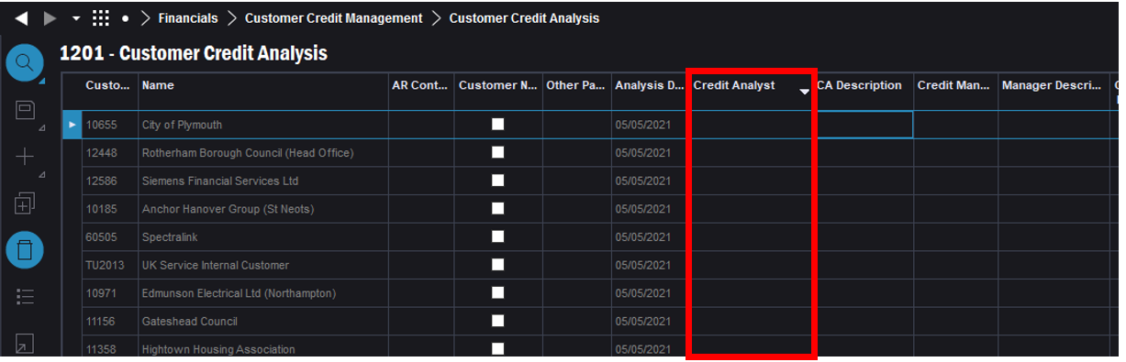

Please add a counter of the number of Customers in this saved search to the lobby element.

**Additional Lobby Elements**

* **(New) Prospects Requiring Credit Check Lobby Element**
* **Amend Target Lobby Element**
* **(New) Lobby Element -Team Targets**

# Lobby Element linking to saved search on Business Opportunities Screen.

* Lobby Element called Prospect Requiring Credit Check.
* Must show total of saved search on lobby element.

The lobby element must link to the Business Opportunities screen.

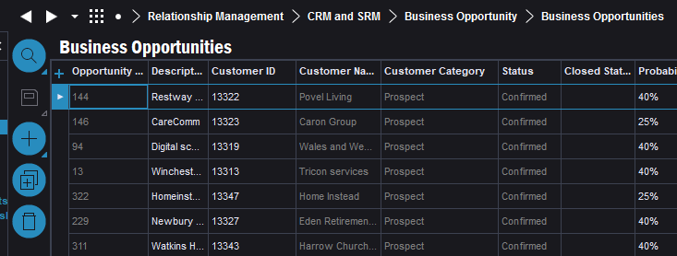

The saved search must filter the Business Opportunities as per the below conditions.

1. **Customer Category:** PROSPECT
2. **STATUS:** Confirmed;In Progress;Unconfirmed.
3. **Prospect Credit Check Date:** BLANK; If Prospect Credit Check Date is older than 6 months. (from Custom field – on Customer screen.)

**Prospect Credit Check Date data is found here (see screenshots below).**

The Business Opportunity is linked to a Customer. On the Customer screen on General Tab the Prospect Credit Check Date is found and is used in this saved search.

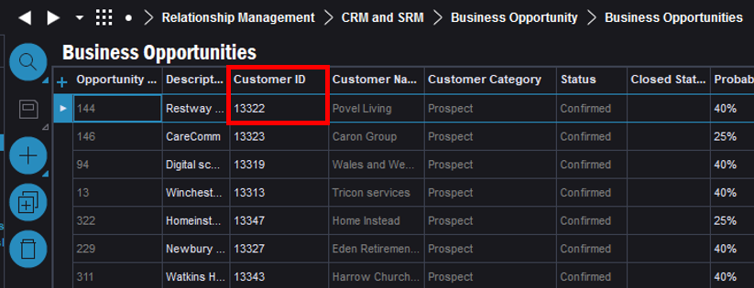

Base the Saved Search on this Field for Prospect Credit Check Date. It is a custom field, see red box in screenshot below.

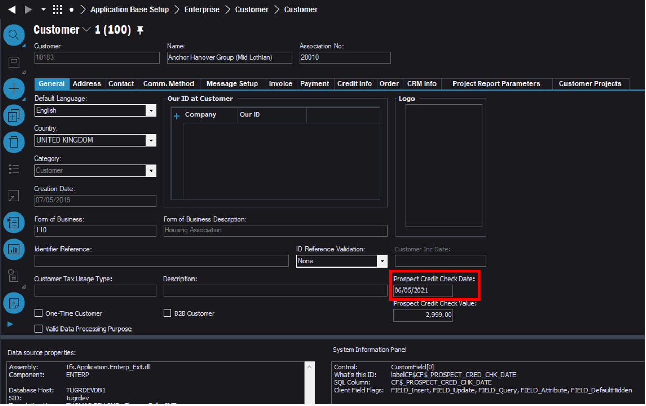

This lobby element must appear on the Credit Analyst Lobby (C0367) and Credit Manager Lobby C0368).

# Amend Existing Targets Lobby Element

* Change title of the below lobby Element to “Target Per Credit Analyst”.
* Add % Column. (Additional Column.)

|  |  |  |  |  |
| --- | --- | --- | --- | --- |
| **Column Name** | **Cash Collected** | **Actual Target** | **Remaining Amount to Hit Target** | **%** |
| **Column Description** | Ensure that data excludes intercompany customers. (Customer Group 20 and 30.) | Actual Target for the Credit Analyst from Credit Targets (Credit Man. basic data) | Target – Cash Collected | Cash Collected/Target*100 |

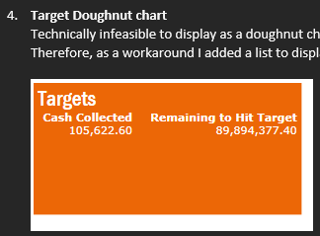

Lobby Element must filter Cash Collected and Remaining Amount by Credit Analyst.

Filter Cash Collected to only show Customers who the Credit Analysis is assigned to and filter the Target of that Credit Analyst.

This must appear on Credit Analyst Lobby and Credit Manager Lobby.

# New Lobby Element “Team Targets”

Lobby element list with the following columns.

|  |  |  |  |  |
| --- | --- | --- | --- | --- |
| **Column Name** | **Cash Collected** | **Remaining Amount** | **Team Target** | **%** |
| **Column Description** | Total of all Cash Collected. | Target – Cash Collected | Target for all Team. (All Credit Control). Filterable by Company. (Data from Credit Targets (Credit Man. Basic data). | Cash Collected/Target*100 |

**Cash Collected**

Displays the Invoice Amount for all Payments where Payment Series ID = CUPAY

The lobby element must filter out any Customers who are Customer Group 20 or 30 (Inter Company). See screenshot below of where this stored.

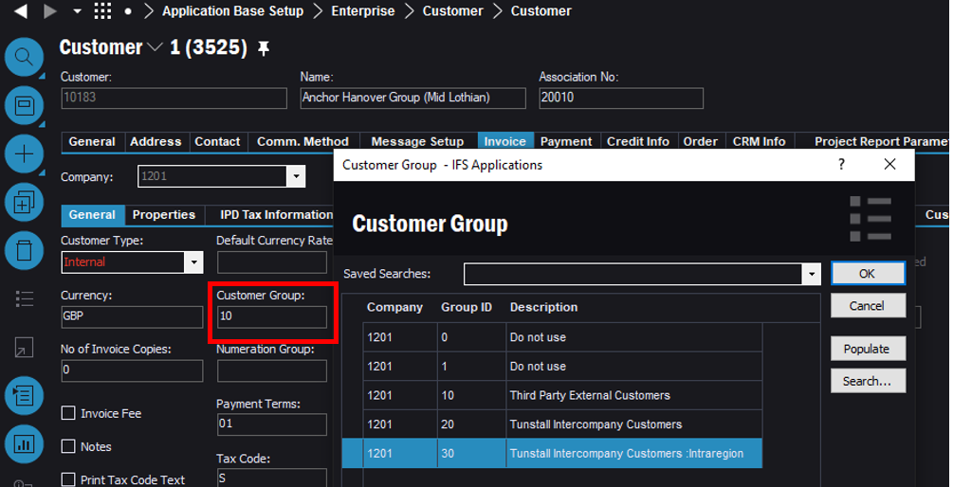

**Team Target Column**

Total of all Credit Analyst’s Targets in that company.

**Target** =Taken from the Credit Targets – in the Credit Management Basic Data screen. (see section “Credit Targets Basic Data” section of this spec.

Remaining Amount Column

**Remaining Amount** = Team Target – Cash Collected

**Target =** Taken from the Credit Targets – in the Credit Management Basic Data screen. (Details of this are in main spec 368).

**Cash Collected** = See above

**% Column**

% = Cash Collected/ Team Target*100

This lobby element must be on the Credit Manager lobby

# Escalated to Finance Controller Tile

By clicking into this tile, the Credit Manager is brought to the Customer Credit Analysis screen.

Here this screen needs to be filtered to only show Customers who have items that have “Status 21 – Escalated to Finance Controller” Invoice Header Notes as the most recent Credit Note. This gives the Credit Manager a view of what is currently being worked on by the Finance Controller.

**Conditional Formatting/Filtering.**

* Filter customers to who have the most recent invoice Credit Header Note set as “Note Status 21 - Escalated to Finance Controller”.
* Filter to only show Customer’s assigned to the Credit Manager.

From the lobby the tile should show the total of invoices that have the most recent Invoice Header Note Status set to the “Note Status 21 - Escalated to Finance Controller”.

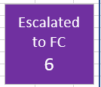

# Technical.

Field Definitions.

<New Field/CLU Definition>

|  |  |  |  |  |  |  |
| --- | --- | --- | --- | --- | --- | --- |
| New DB Object Name | DB Object Item/Field Names | Item Description | Item Data Type | Item Syntax | Calculation Spec, if Derived | LOVs/Enums/Is Mandatory? |
|  |  |  |  |  |  |  |
|  |  |  |  |  |  |  |
|  |  |  |  |  |  |  |
|  |  |  |  |  |  |  |
|  |  |  |  |  |  |  |
|  |  |  |  |  |  |  |
|  |  |  |  |  |  |  |
|  |  |  |  |  |  |  |
|  |  |  |  |  |  |  |
|  |  |  |  |  |  |  |
|  |  |  |  |  |  |  |
|  |  |  |  |  |  |  |

Security

<Define security controls> (Who needs access to this and will it be restricted from any other users etc)

* Finance Manager. Full access.
* Credit Manager. Full access.
* Credit Analysts should not have access to this lobby.

Companies

Applies to the following companies. All.

|  |  |
| --- | --- |
| **Company** | **Required (Y/N)** |
| 1201 | Y |
| TBC |  |
|  |  |

Data Migration

<Describe any data migration impacts this development may have – i.e additional data to be migrated>

Test Steps

<Steps that needs to be taken to test this change. Please provide expected results> Updated post solution.

|  |  |  |
| --- | --- | --- |
| **No** | **Script\Test Steps** | **Expected Result** |
| 1 | Run “Credit Manager Lobby” | See the required tiles and be able to filter lobby by Credit Manager by a drop-down list. |
| 2 | Click Call List Tile | Navigated to Customer Credit Analysis screen with predetermined saved searches.   * Filter to show customers whom have Invoice Header Notes that have a Follow Up Date older than or equal to today’s date. * Filter the Call List to show Customers that have no Invoice Credit Notes attached to them. * Filter list to exclude customers where the most recent Invoice Header Credit Note has a Note status of: “Note Status 1 – Complete” or “Note Status 2 – Escalated to Credit Manager”. |
| 3 | Click into Overdue Debt Tile | See the Customer Credit Analysis screen with all of the Credit Manager’s assigned customers in the screen. |
| 4 | Click into All Overdue Debt Tile | See the Customer Credit Analysis screen with all customers in the screen. |
| 5 | Click into Customer Payment on Account Tile | See a Tile called “Customer Payment on Account”. Within this Tile Customer Analysis screen will be shown with a filtered applied to the list to only show customers with Customer Payments on Account items. Tile will show the total CUPOA from the lobby. For the Credit Manager’s customers. |
| 6 | Click into Top 10 Customer Debt Tile | See a screen that has the Largest Customer Debt by Aging Bucket. Customer Number, Customer Name and Balance in Bucket as column headers and customer debt as rows |
| 7 | Click into Top 10 Largest Items Tile | See a screen showing the largest overdue debt by invoice amount for only Items relating to that Credit Analyst. |
| 8 | Blocked Customer Tile | See a list of the Customers that are assigned to the Credit Manager that have been blocked |
| 9 | Click into Items Escalated Items to Review | Screen will be filtered to only show Customers who have items that have “Status 2 – Escalated to Credit Manager” Invoice Header Notes as the most recent Credit Note. |
| 10 | Click into Follow Up Date Missed Tile | * Selecting this Tile brings the Credit Manager to the Follow Up Date Missed screen (Customer Credit Analysis screen). * This screen will be filtered to only contain Customers who have invoice Credit Header Notes that the most recent follow up date is 21 days old or more. * From the Credit Manager Lobby, this tile will have the number of items that are needing input. |
| 11 | Click Overdue queries | See Customer Credit Analysis screen that only contains customers invoice header note status set to In Query and the follow up date is in the future. For the Credit Manager’s customers. |
| 12 | Click into Open queries | See Customer Credit Analysis screen that only contains customers invoice header note status set to In Query and the follow up date is in the past. For the Credit Manager’s customers. |
| 13 | Click into All queries | See Customer Credit Analysis screen that only contains customers invoice header note status set to In Query |
| 14 | Click Legal Customers | See Customer Credit Analysis screen that only contains customers with invoice note header status set to Legal. |
| 15 | Targets Chart | See the target basic data reflected in a chart on this lobby for the current month. |
| 16 | Click Ad Hoc Partial Statement | Click the tile, input a customer number and be navigated to the customer analysis screen for that customer. |
| 17 | Click Ad Hoc Full Statement | Click the tile, input a customer number and see a report dialogue box where the user can print or email the Full Statement to the customer. |
| 18 | Click Follow Up Date Missed tile | See Customer Credit Analysis screen that only contains customers with invoice note header follow up dates that are older than 4 days. |
| 19 | Click Large Invoice Courtesy calls | See Customer Credit Analysis screen that only contains customers with unpaid invoices that are over £10,000. For the credit manager’s customers. |
| 20 | Click Escalated to Financial Controller tile | See Customer Credit Analysis screen that only contains customers with invoice note header status set to “Escalated to Financial Controller”. |
| 21 | Click into All Top 10 Largest Items Tile | See a screen showing the largest overdue debt by invoice amount. |
| 22 | Click into All Top 10 Customer Debt Tile | See a screen that has the Largest Customer Debt by Aging Bucket. Customer Number, Customer Name and Balance in Bucket as column headers and customer debt as rows |
| 23 | Click into All Customer Payment on Account Tile | See a Tile called “Customer Payment on Account”. Within this Tile Customer Analysis screen will be shown with a filtered applied to the list to only show customers with Customer Payments on Account items. Tile will show the total CUPOA from the lobby. |
| 24 | Click into Age Debt per Stat Group Tile | Go into a screen that shows the debt by customer stat group for all customers. |
| 25 | Click into All Customer Credit Usage Tile | See Customer Credit Analysis screen that shows the % Credit limit usage for all customers. Sorted by largest % descending. |
| 26 | Click into All Credit Review Required Tile | See customer credit analysis screen of customers whose credit limits have not been changed for 11 months. |
| 27 | Click into Customer Credit Usage Tile | See Customer Credit Analysis screen that shows the % Credit limit usage for all customers. Sorted by largest % descending. For all Credit Manager’s customers. |
| 28 | Click into Credit Review Required Tile | See customer credit analysis screen of customers whose credit limits have not been changed for 11 months. For all Credit Manager’s customers. |
| 29 | Click into All Blocked Customers tile | See a list of the Customers that are assigned to the Credit Manager that have been blocked through the Customer credit analysis screen. |

Technical Implementation

<Completed by the technical developer - Technical solution, list packages, functions, Custom menus created etc >

# Delivery Notes

1. Grant permissions to **‘Tunstall Credit Manager’** lobby and 6 secondary drill-down lobbies **Top 10 Total Customer Debt**

**Top 10 Items by Bucket**

**All Top 10 Total Customer Debt per Aging Bucket**

**All Top 10 Items by Bucket**

**Age of Debt: Per Customer Stat Group**

**Credit Analyst - Call List**

Permission sets: IFS_ALL, FND_QUICK_REPORTS

1. Lobby parameters:

* Company
* Credit Manager
* Target Period (MM-YYYY format ex: 05-2021 for May 2021)
* Credit Analyst

1. Import the ACP for C0368 (ACP Finance) and publish it.
2. Reload configuration on **‘Credit Management Basic Data’** screen to make **‘Credit Targets’** tab available and arrange the column order.
3. If the custom columns are not visible in ‘Customer Credit Analysis’ screen please do Reload Configurations, and use ‘Column Chooser’ to add them to the screen.

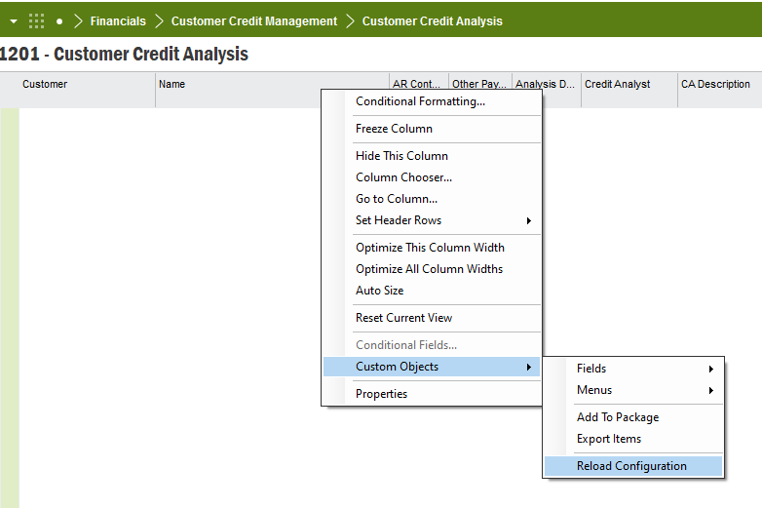

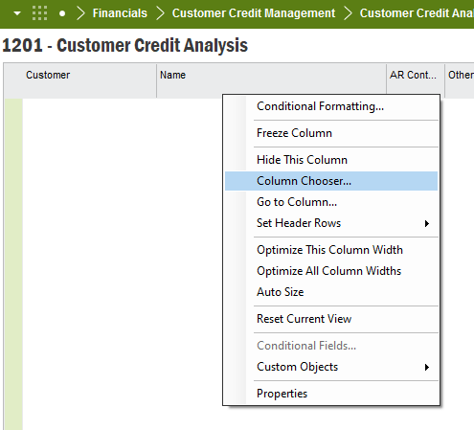

1. Lobby elements

| **Element name** | **IAL** | **Custom Function** | **Remarks** |
| --- | --- | --- | --- |
| Call List |  | C_EA_Customization_Util_API.Check_Inv_Header_CM() | Bucket 1 is taken as “Aging Bucket -Current “  As there can be multiple invoices for the customer, each invoice should be considered in filter logic. So, the customer can get filtered if one of its invoices satisfy either one of the conditions.  Eg:  Invoice 1 is satisfying condition 1 🡪 filtered to Call List  Invoice 2 is satisfying condition 2 🡪 filtered to Call List  Invoice 1 may not satisfy condition 2 and 3 |
| Overdue Debt |  |  |  |
| Top 10 Total Customer Debt | C_CUST_DEBT_PER_BUCKET1, C_CUST_DEBT_PER_BUCKET2, C_CUST_DEBT_PER_BUCKET3, C_CUST_DEBT_PER_BUCKET4, C_CUST_DEBT_PER_BUCKET5, C_CUST_DEBT_PER_BUCKET6 |  | Added as a secondary drill down lobby screen Lobby name: Top 10 Total Customer Debt |
| All Top 10 Total Customer Debt | C_CUST_DEBT_PER_BUCKET1, C_CUST_DEBT_PER_BUCKET2, C_CUST_DEBT_PER_BUCKET3, C_CUST_DEBT_PER_BUCKET4, C_CUST_DEBT_PER_BUCKET5, C_CUST_DEBT_PER_BUCKET6 |  | Added as a secondary drill down lobby screen Lobby name: All Top 10 Total Customer Debt per Aging Bucket |
| Top 10 Items by Aging Bucket | C_INV_PER_BUCKET1, C_INV_PER_BUCKET2, C_INV_PER_BUCKET3, C_INV_PER_BUCKET4, C_INV_PER_BUCKET5, C_INV_PER_BUCKET6 |  | Added as a secondary drill down lobby screen Lobby name: Top 10 Items By Bucket |
| All Top 10 Items by Aging Bucket | C_INV_PER_BUCKET1, C_INV_PER_BUCKET2, C_INV_PER_BUCKET3, C_INV_PER_BUCKET4, C_INV_PER_BUCKET5, C_INV_PER_BUCKET6 |  | Added as a secondary drill down lobby screen Lobby name: All Top 10 Items by Aging Bucket |
| Blocked Customers |  |  |  |
| All Blocked Customers |  |  |  |
| Customer Payment On Account | C_CUSTOMER_PAY_ACCOUNT |  |  |
| All Customer Payment On Account | C_CUSTOMER_PAY_ACCOUNT |  |  |
| Escalated to Credit Manager |  | C_EA_Customization_Util_API.Check_Escalated_CM() |  |
| Follow Up Date Missed |  | C_EA_Customization_Util_API.Check_Followup_Date_Mised() |  |
| Age of Debt: Per Customer Stat Group | C_DEBT_STAT_GRP_BUCKET1, C_DEBT_STAT_GRP_BUCKET2, C_DEBT_STAT_GRP_BUCKET3, C_DEBT_STAT_GRP_BUCKET4, C_DEBT_STAT_GRP_BUCKET5, C_DEBT_STAT_GRP_BUCKET6 |  | Added as a secondary drill down lobby screen Lobby name: Age of Debt: Per Customer Stat Group |
| Credit Targets basic data |  |  | Custom LU : CreditTargets 'Company' is Primary Key for Credit Analyst view, therefore need to have Company column in the new target basic data window to maintain the key mapping. To reflect in LOV for Credit Analyst, company is added in the Display Text as <Company> - <Credit Analyst Code> format. User can filter Credit Targets basic data by searching for the wanted company as same as for a common framework window, but will not be filtered by default from the header company as it is not supported by the framework.  Custom Event **‘C_VALIDATE_CREDIT_TARGETS’**  is added to validate the inputs for Credit Targets basic data screen. |
| Monthly Target % by Credit Analyst Chart |  | C_EA_Customization_Util_API.get_cash_collected(), C_EA_Customization_Util_API.get_period_target() |  |
| Open Items by Credit Analyst |  |  | Technically infeasible to navigate to credit analyst’s Call List from the bar chart. It is possible to navigate to Customer Credit Analysis screen, but framework does not support to add the conditional filter that Call List requires. Workaround : navigate to a secondary lobby that carried Call List tile, and the user can enter the Credit Analyst code as a lobby parameter to see the call list. |
| Largest Invoice Courtesy Call | C_LARGEST_INVOICE_CALLS |  |  |
| Legal Customers |  | C_EA_Customization_Util_API.Check_Credit_Legal_CM() |  |
| Open Queries |  | C_EA_Customization_Util_API.Check_Credit_Note_Queries_CM() |  |
| Overdue Queries |  | C_EA_Customization_Util_API.Check_Credit_Note_Queries_CM() |  |
| All Queries (Overdue and Open) |  | C_EA_Customization_Util_API.Check_Cr_Note_Queries_All_CM() | element name: Items In Query (All) |
| Ad Hoc Sending of Send Full Statement |  |  | Changed as a link to the customer analysis screen, after clarified with business, as Technically infeasible to popup a dialog box from a lobby element. |
| Ad Hoc Sending of Partial Statement |  |  | Not configured as advised not to add it after clarification from business |
| Customers with No Credit Analyst |  |  |  |
| Prospect Requiring Credit Check |  |  |  |
| Targets |  | C_EA_Customization_Util_API.get_period_target(), C_EA_Customization_Util_API.get_cash_collected() |  |
| Team Targets |  | C_EA_Customization_Util_API.Get_Team_Period_Target(), C_EA_Customization_Util_API.Get_Team_Cash_Collected() |  |
| Escalated to Finance Controller |  | C_EA_Customization_Util_API.Check_Credit_Escalated_FC() |  |

1. Grant permission to IAL objects mentioned in above table.

